|  |
| --- |
| This project report is submitted as part of Programming Exercises course, Summer Semester 2015.  5/31/2015 |

|  |
| --- |
| Frankfurt University of Applied Science |
| Kakuro Solver |
| Design Plan |
| By: Purit Thong-on  Marcus Vinicius  Piyaphat Russamitinakornkul 1106291 |
| Course: Programming Exercises, Summer Semester 2015 |
| Instructor: Professor Doctor Doina Logofătu |

Introduction to Kakuro

Kakuro is a Japanese puzzle game with a table of numbers. Each cell in a table can either colored or white cell. There are fixed numbers in the colored cells, which is generally red or black and never changes. Players must fill in the white cells with numbers 1-9 under 4 conditions:

1. Consecutive white cells in horizontal of each row must contain a number which sums up together equal to the number of the colored cell to the left.
2. Consecutive white cells in vertical of each column must contain a number which sums up together equal to the number of the colored cell to the top.
3. Within those consecutive cells, all the numbers must be **distinct**.
4. Every white cell must be filled with a number. No blank cells allowed!

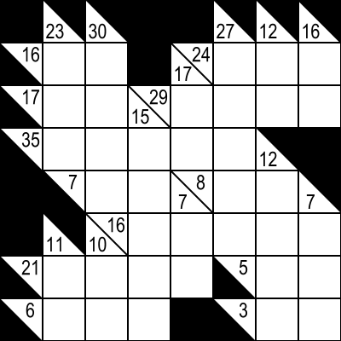 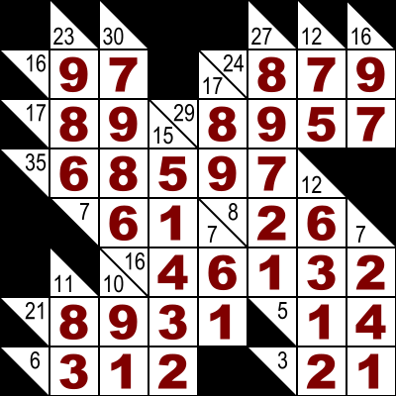

Kakuro Table Kakuro Puzzle Solved

Implementation Method

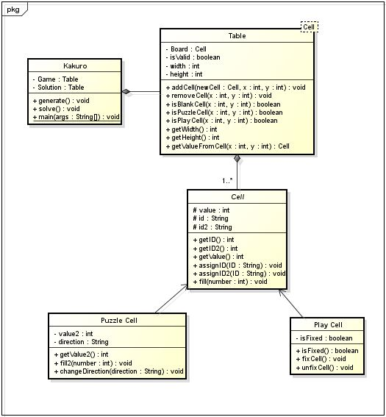

The best way to implement Kakuro puzzles is using a 2-dimensional array cells to implement a Kakuro table. Each cell in the table can either be a “Puzzle Cell” which is a colored cell or “Play Cell” which is for filling numbers to play (white cells).

Each cell has 2 IDs which is used to find its connection to other cells. All white cells with the same ID will share the ID with one colored cell to indicate that all values in the white cell sum up to exactly the value in the colored cell with the same id.

A colored cell can contain 2 values. Each value has an ID to indicate the direction of the white cells. A colored cell without numbers can be represented with a “null” value to indicate that there is nothing on that cell.

Reference

## About Kakuro:

Wikipedia. “Kakuro”. [Online].

Available <http://en.wikipedia.org/wiki/Kakuro> (27 May 2015).

## Play Kakuro Online:

Marco Volberg. “Kakuro”. [Online].

Available <http://www.kakuro-knacker.de/> (Accessed 31 May 2015).

## Implementing Kakuro Source Code Example:

ctimmons. “cs_kakuro_solver”. [Online].

Available <https://github.com/ctimmons/cs_kakuro_solver> (27 January 2013)

## Kakuro Solving:

Sourendu Gupta. “Introduction: The mathematics of Kakuro”. [Online].

Available <http://theory.tifr.res.in/~sgupta/kakuro/index.html> (23 November 2006).